**Disciplined Entrepreneurship Workbook**

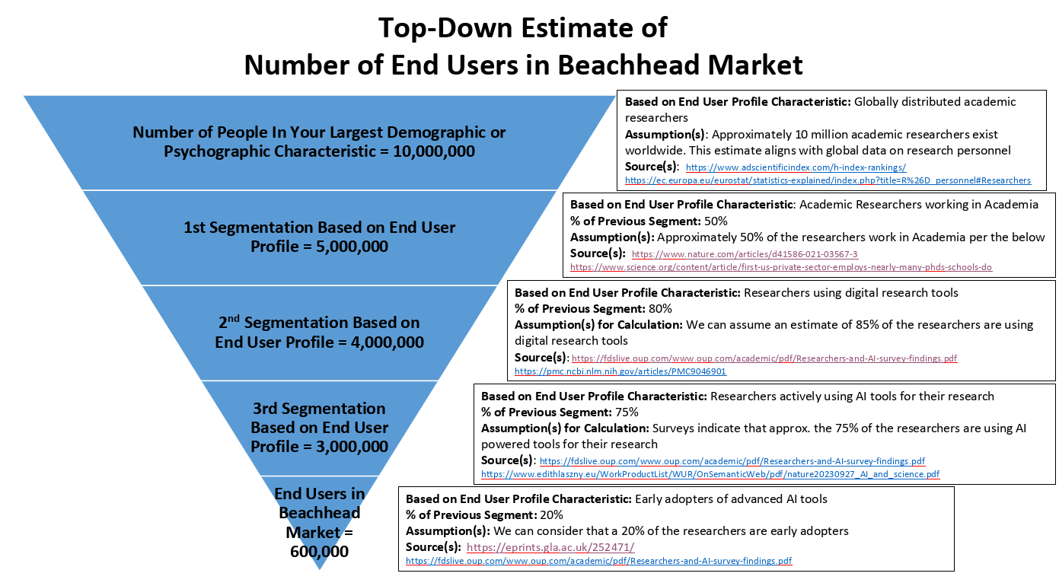

Step 4: Calculate Total Addressable Market (TAM) for Beachhead Market Worksheets

|  |  |  |  |
| --- | --- | --- | --- |
| **I.** | **One Time Charge Data Point** | | |
| Ia | Estimation of price per unit | | €20 per month |
| Ib | Number of units needed per end user | | 12 (per year) |
| Ic | Average Life Relevant? (assume repurchase) | | Yes – repurchase every cycle |
| Id | Average Life of Product in year | | 3 years |
| Ie | Annualized Revenue (Ia*Ib) (Data Point 1) | | €20 × 12 = €240 per year |
| **II.** | **Budget Available Data Points** | | |
| IIa | Current Spend per end user (Data Point 2) | | €500 |
| IIb | Total budget for the end user | | €2,000 |
| IIc | What % of budget could go to this solution reasonably? | | €20% |
| IId | Annualize Revenue (IIb*IIc) (Data Point 3) | | €2,000 × 20% = €400 per year |
| **III** | **Comparables** | |  |
| IIIa | Who are the comparable for your business? | | Sakana, Google’s Co-Scientist, OpenAI DeepResearch |
| IIIb | What are the comparable products? | | Autonomous research assistants (e.g., Sakana), prompt-driven research tools (e.g., Google’s Co-Scientist), AI-driven comprehensive research synthesis ((e.g., OpenAI's Deep Research) |
| IIIc | What is the comparable converted to similar annualize revenue (Data Points 4 plus however many more you deem relevant) | | Market research suggests comparable  products generate approximately €500–€1000  per end user |
| **IV** | **Interpreting the Results** | | |
| IVa | Consensus on estimate of annualized revenue per end user (a range is fine) | | The estimated annualized revenue per end user is €250 - €1000. |
|  | How did you end up at this number/range? | This is based on market research, average pricing of comparable products and our purpose for quickly gaining market share. | |

Now the final items beyond just a beachhead market TAM are the other dimensions that are important to provide more meaning to the overall number. A $10M beachhead market TAM that has 99% profitability where you can win 100% market share in less than a year, which also happens to be growing at 30% a year, is totally different than a $10M beachhead market TAM with 10% profitability where you will only get 10% market share after 3 years of effort and the market is shrinking each year.

This information should be collected and then added in to fill out the Top-Down TAM Analysis Summary below to give a robust sense of the economic attractiveness of market characteristics of the beachhead market.

|  |  |  |  |  |
| --- | --- | --- | --- | --- |
| Top-Down TAM Analysis Summary | | | | |
| 1 | Total # of end users in the broad market segment | 10,000,000 | Source/ Based on: | <https://www.adscientificindex.com/h-index-rankings/>  <https://ec.europa.eu/eurostat/statistics-explained/index.php?title=R%26D_personnel#Researchers>  Approximately 10 million academic researchers exist worldwide. This estimate aligns with global data on research personnel. |
| 2 | Total # of end users in the targeted sub-segment your BHM | 600,000 | Source/ Based on: | <https://eprints.gla.ac.uk/252471/>  <https://fdslive.oup.com/www.oup.com/academic/pdf/Researchers-and-AI-survey-findings.pdf>  We can consider that a 20% of the researchers are early adopters of AI research tools |
| 3 | Annual monetizable revenue per end user | €250 - €1000 | Source/ Based on: | Based on market research, average pricing of comparable products and our purpose for quickly gaining market share |
| 4 | Estimate of Top-Down TAM (line 2 times line 3) | €150,000,000 to  €600,000,000 |  | €375,000,000 |
| 5 | Estimate of Range of Profitability for Your Product | 10% - 30%  (Net Profit) | Source/ Based on: | Based on Software business margins and market research |
| 6 | Estimated CAGR (Compound Annual Growth Rate) | 30% | Source/ Based on: | Market Growth Trends |
| 7 | Estimated Time to Achieve 20% Market Share | 1 year | Source/ Based on: | Early adopter trends and rapid scaling potential |
| 8 | Anticipated Market Share Achieved if You are Reasonably Successful | 20% | Source/ Based on: | Conservative market penetration estimate |
|  | What are the 3 top assumptions that could affect the attractiveness of the beachhead market for your product (besides the product itself)? | 1.Adoption Rate Assumption: Approximately 80% of academic researchers are digitally engaged and around 20% of these will be early adopters of an AI-enhanced scientific discovery platform.  2.Pricing & Budget Allocation: Academic institutions are expected to allocate about 20% of their digital tools budget (with a total budget around €2,000 per user annually) to innovative AI solutions.  3.Market Growth & Technological Acceptance: Continued growth in digital  research tools and increasing reliance on AI, with the market growing at a  conservative CAGR of 30% per year. | | |

Based on this summary analysis, use the below checklist to assess whether your beachhead market is a good size:

|  |  |  |  |
| --- | --- | --- | --- |
| Checklist After TAM Analysis of Beachhead Market | | | |
|  |  | Yes | No |
| 1 | Is the market big enough to be interesting? | X |  |
| 2 | Is it reasonable in size for us to achieve meaningful word of mouth, meaning it is not too big? | X |  |
| 3 | Is it possible to get to cash flow positive in this market in a reasonable period of time (typically 3 years but it might be shorter or longer depending on the industry)? Note: This question takes into consideration the extra 4 factors described above | X |  |
| 4 | Do I still feel good about this beachhead market as our initial market? | X |  |

If the answer to any of these is no, consider carefully before you move forward. Many of the high-profile entrepreneurs who have access to significant investment capital, or have a very strong personal balance sheet themselves, can ignore #3, but I would advise you to not ignore this question otherwise. It might be the second most important question for your survival. The most important question is the last one, because if you don’t feel good about this market, you need to figure out why.

## ADVANCED TOPICS: BOTTOM-UP TAM ANALYSIS

As mentioned, a bottom-up analysis is extremely powerful and gives you invaluable insights that are not generally possible through secondary research. Bottom-up analysis is also very time-consuming and difficult to get information for. If you are unsure about your market or your commitment to this idea, skip this part and come back later when you are more confident about your beachhead market and have a deeper understanding of the market. Most plans rely on top-down analysis, and while I think it’s insufficient, it is the reality that bottom-up analysis is much, much harder to do.

The below worksheet uses a concept called “end user density” which allows you to complete a bottom-up analysis without the need to identify every single end user in a market, since that process can be prohibitively expensive in terms of time consumed.

To calculate end user density, you’ll first need some way to divide up the market into countable units. For instance, in the SensAble example in *Disciplined Entrepreneurship*, we sold to companies that employed industrial designers, and they defined their countable entity as overall number of employees. Their resulting “designer density” for their market was expressed as the number of designers per thousand employees.

For a consumer product, your countable unit could be population, a specific socioeconomic segment of the population, the number of people who own another product, etc. For businesses it may be number of employees, revenue, products released each year, number of customers that company has, etc. These units depend on your situation. Clever choice of countable unit for density will give credibility to your TAM estimate, so spend some time to optimize your choice on this unit, understanding it is still an estimate.

Once you have defined your countable unit, go to three instances of this unit and “count noses,” determine exactly how many end users are within that countable unit. Also determine how many people overall are in that countable unit.

Then, for each instance, determine what the annualized revenue per end user is, based on the unique circumstances of each instance. Do not guess, ask the people from this instance of the countable unit!

### Bottom-Up TAM Analysis Worksheet

**What countable unit are you using for end user density?**

Research Departments at research-intensive Universities: this unit captures distinct groups where academic researchers work together and where technology purchasing decisions may be more coordinated.

**What are three instances of this countable unit you will be using to “count noses”?**

1. Top 10 research-intensive universities in North America

2. 20 research institutes in Europe

3. 30 technical universities in MENA region

|  |  |  |  |
| --- | --- | --- | --- |
|  | **Instance 1:**  Top 10 research-intensive universities in North America | **Instance 2:**  20 research institutes in Europe | **Instance 3:**  30 technical universities in MENA region |
| **Who did you speak to in order to gather this info?** | Department heads and research coordinators | Department heads and research coordinators | Department heads and research coordinators |
| **# of end users** | ~1,500 | ~1,000 | ~1,200 |
| **# of people in the countable unit** | ~6,000 | ~5,000 | ~8,000 |
| **Density ratio (# end users / # people in countable unit)** | 25% | 20% | 15% |
| **How representative of the whole market do you believe this instance is?** | Very High | High | High |
| **In this instance, what is your estimate of the annualized revenue per end user?** | €750 | €500 | €300 |

**Based on the above table, what is a reasonable estimate of the end user density?** 20% - Across these representative institutions, approximately 20% of the overall faculty population appears to be in the end users category.

**What is a reasonable estimate of the annualized revenue per end user?** €500 - This aligns with the subscription pricing model and is supported by both top-down pricing assumptions and direct feedback from potential users.

**Based on the end user density, what is a reasonable estimate for the number of end users in the market?**

If the global academic research workforce working in academia is roughly 5 million, then with a 20% end user density the potential end users are approximately 1,000,000.

**What is a reasonable estimate for the TAM (# end users multiplied by annualized revenue per end user)?**

1,000,000 end users x €500/year = € 500,000,000

|  |  |  |  |
| --- | --- | --- | --- |
| Four additional factors to consider: | | | |
| Estimate of Range of Profitability for Your Product | 10% - 30%  (Net Profit) | Based on: | The delivery of the AI Co-Scientist is fully digital, but we can assume high marketing/sales costs and R&D expenses for continuous AI model improvements. | |
| Estimated CAGR (Compound Annual Growth Rate) | 30% | Based on: | AI in Higher Education Market is projected to grow from USD 1.6 billion in 2023 to USD 25.7 billion by 2033 | |
| Estimated Time to Achieve 20% Market Share | 1 year | Based on: | Early adopter trends and the rapid scaling potential in academia | |
| Anticipated Market Share Achieved if You are Reasonably Successful | 20% | Based on: | Conservative market penetration estimates in academic sectors | |

**1. Comparing your top-down and bottom-up analyses, which do you believe has more credibility? Why?**

I believe that the Bottom-Up Analysis is generally more credible than the Top-Down Analysis because it uses granular data from specific, countable units like research institutions and labs, providing realistic market estimates directly tied to our product. It offers better alignment with user needs and willingness to pay, while top-down analysis relies on broad market assumptions that can overestimate potential. However, the bottom-up approach is more time-consuming and requires extensive data collection, but ultimately provides a clearer and more reliable market estimation.

2. **If you blend the two estimations, what is your final TAM size? What factors would make the TAM lower than you calculated? What are the factors that would drive the TAM much higher?**

The final blended TAM size can be approximately € 437,500,000 per the top-down and boot-up analysis:

(€500,000,000 per bottom-up + €375,000,000 per top-down)/2

Factors That Could Lower the TAM: Lower adoption rates due to budget constraints, resistance to AI tools, or funding cuts in academia can reduce the TAM. Increased competition from other AI products can also capture market share, limiting revenue potential.

Factors That Could Drive the TAM Higher: Faster AI adoption which can be driven by successful case studies or technological breakthroughs, and offering premium features can boost the TAM. Improved value propositions and successful integrations in academia can further drive market growth.